# *Deploy Flask/Python Web Application Using Git,Github,Jenkins,Terraform,Route53 In Aws*

**what is Flask?**

* Flask is a small and lightweight python web application framework that provides useful tools and feature that make creating web application in python easier.
* It gives developers flexibility and it is a more accessible framework for new developer since you can build a web application quickly using only a single python file.

**What is python?**

* It is a computer programming language often used to build websites and software automate tasks, and conduct data analysis

**What is PIP?**

* PIP is a package manager python packages, or modules

**Note:** if you have python version3.4 or later PIP is include by default.

**Pre-requisites:**

1. AWS account
2. IAM user
3. Terminal
4. Basic understand pf Python/Flask

**Services and Tools used:**

Aws service

1. IAM
2. VPC
3. EC2
4. ROUTE53

Devops Tools

1. Github
2. Jenkins
3. Terraform

**Step By Step Procedure:**

* Create and Login AWS Root Account
* Create a VPC along with subnets, route tables, internet gateway, elastic IP(if required),NACL(optional).

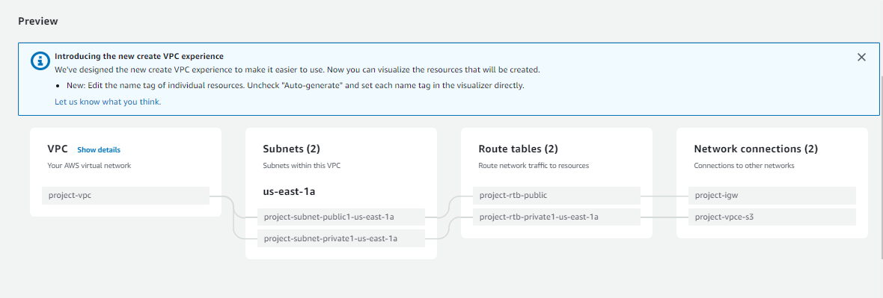

* Create security group with respective ports
* SSH = 22
* HTTP = 80
* HTTPS = 443
* TCP = 8080,8000,7000
* Create EC2 instance launch with SSH
* Amazon Linux, Ubuntu, RHEL
* Update ubuntu machine.

*# sudo apt update*

* Full upgrade the machine.

*# sudo apt-get full-upgrade -y*

* Install required packages or tools related for deployment project.

*# sudo apt-get install python3-pip*

* Install git and clone the project source code from Github

***#sudo git clone https://github.com/j800494803/flask-library-app.git***

* Now, go to the source code directory

*# cd flask-library-app/*

* Now, install requirements packages

*#pip3 install -r requirements.txt*

* Run Flask server

*# python3 app.py*

* Here, after running python app.py it will generate localhost IP address. We can’t access web app with that IP address. Then we want to edit the file app.py with some details.

*# sudo vi app.py*

* Go to very bottom of the file and paste this below text and save the file.

*app.run(host='0.0.0.0', port=8000, debug=True)*

* Now, again run the Flask server by using below command

*# python3 app.py*

* Now , copy EC2 instance public IP and give port number and search in web browser.

*IP:8000*

* We will get output like this

